Robot arm control by voice draff:

how it works?
User Voice
↓
Voice Recognition
↓
Command Parsing
↓
Object Detection (Camera + CV)
↓
Robotic Arm Control Logic
↓
Actuation (pick/place/move)

1. Voice recognition:
Microphone Input: Record voice commands.
Speech-to-Text (STT): Convert voice to text using:
- Offline: Vosk, PocketSphinx, speechrecognition
- Online: Google Speech-to-Text, Whisper API
2. Command Parsing:
- Use NLP or keyword-based parsing.
- Example: "Pick up the red ball" → {"action": "pick", "object": "red ball"}
3. Object Detection (Camera + CV)
Camera Setup:
- Use Laptop and USB webcam to capture video.
- Use a webcam or Raspberry Pi camera to capture video.
Object Detection:
- Use pre-trained models (YOLO, SSD, etc.).
- Train a custom model.
Object Localization:
- Convert pixel positions to real-world coordinates.
- Use calibration and perspective transformation in some cases.
4. Actuation :
Working principles:
Defining the coordinate systems.
Determining the desired end-effector position and orientation.
Calculating the required joint angles (inverse kinematics).
Planning a smooth trajectory.
Implementing control algorithms to achieve the desired movement.
Using sensors for feedback and error correction.
Hardware Interface:
- Use Arduino to control servos.
Pick and Place Logic:
- Match object coordinates from vision with reachable positions.
- Move the arm accordingly.
This is the state diagram for the arm:
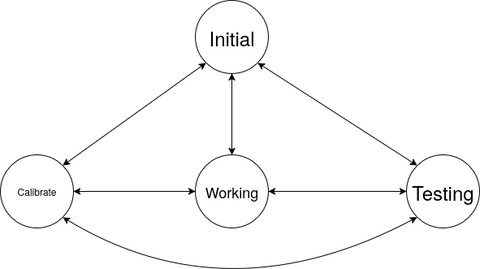
Initial : a state that is the end point of the arm at the initialize which is (0;0;0) in the 3D coordinate system.
working: a state that is the arm in the working base on a given coordinate.
Testing : a state that the arm will be testing all servos independent from that can diagnose the fault of each joint.
Calibrate: a state that each servo checking itself to confirm a value suitable for movement and write it to eeprom.

